

An Undergraduate Internship/Project on Topic

**Blood Donor**

By

**Tonmoy Saha**

Student ID: **1610216**

**Summer, 2021**

Supervisor:

MD. Fahad Monir

Department of Computer Science & Engineering

Independent University, Bangladesh

**June 17, 2021**

**Dissertation submitted in partial fulfilment for the degree of Bachelor of Science in Computer Science**

**Department of Computer Science & Engineering**

**Independent University, Bangladesh**

# Attestation

This is to certify that the report titled “**Blood Donor**- A web-based Blood Bank" was completed by Tonmoy Saha (1610216) submitted in partial fulfilment of the requirement for the Degree of Computer Science from Independent University, Bangladesh (IUB). It has been completed under the guidance of Md. Fahad Monir (Internal Supervisor) and Mr Abid Ibn Habib (External Supervisor). I also certify that all my work is original and has not been submitted earlier to this university or any other institution. All the source of information used in this Project Report has been duly acknowledged in it.

_______________________ _______________________

Signature Date

# Acknowledgement

I would like to take this opportunity to express my gratitude to everyone who helped me throughout the course. I am grateful for their aspiring guidance, invaluable constructive criticism, and friendly advice throughout the internship. I am grateful to them for sharing their honest and enlightening perspectives on a variety of course-related issues.

I am grateful to Independent University, Bangladesh (IUB) for offering me this course and I express my thanks to my faculty and internship supervisor, MD Fahad Monir.

I want to stretch out my earnest gratitude to him. I am profoundly obligated to Independent University, Bangladesh (IUB) for their direction and consistent supervision for giving important data with respect to the course.

I am very much grateful towards my external supervisor, Mr Abid Ibn Habib for the guidance and support that I needed for the fulfilment of my internship and project. I might want to offer my extraordinary thanks and gratitude to the JBL Drug Laboratories IT Department developers and employees for giving me such consideration, time and directing through the internship.

I would also want to thank my parents for who have supported me financially and have always believed in me and always motivated me to accomplish the things that I achieved.

# Letter of Transmittal

Date:

Md. Fahad Monir

School of Computer Science and Engineering

Independent University Bangladesh.

Subject: Submission of Internship Report.

Dear Sir,

It is a great pleasure to submit my report on my Internship at JBL Drug Laboratories. I have tried to narrate my project works, achievements and experiences in this report. All the works presented here are done with utmost sincerity and honesty.

During the internship period, I have served in JBL Drug Laboratories for three months where I have not only gained real-life work experience but understood the process of the department and its various aspects. This report includes a detailed review of the office as well as the functionalities of the department. As a document of my effort during the internship periods I have conducted all the project works that I have done during my internship periods, especially their requirement, functionalities, and technical specifications.

I pray and hope this report will be quite interesting and fulfil your expectations. I have tried my best to avoid my deficiencies and hope that my report will satisfy you. I also would like to thank you again for giving me the opportunity to submit this report.

Sincerely,

Tonmoy Saha

ID- 1610216

# Evaluation Committee

.....................................................................

Signature

.....................................................................

Name

.....................................................................

Supervisor

.....................................................................

Signature

.....................................................................

Name

.....................................................................

Internal Examiner

.....................................................................

Signature

.....................................................................

Name

.....................................................................

External Examiner

.....................................................................

Signature

.....................................................................

Name

.....................................................................

Convener

# Abstract

“**Blood donor**” is a web-based Blood Bank. It is a platform that creates a connection between Hospitals (who has blood) and Receivers (who needs blood).​ My internship was to develop this project as a Non-Profit Project/Business by JBL Drug Laboratories Limited.

Firstly, the main duty was Brainstorming to come up with ideas to design the whole mechanism. It needed to be simple and also easy to use (user friendly). The website app was required to store all data in a database that was secured and could be accessed/edited by authorized persons only.

"**Blood Donor** - a web-based blood bank" provides a list of blood (available) and Hospital (who has these) in your area. A large number of blood donors and hospitals attracted using a Web-Based application. Since almost everyone carries a mobile phone, it ensures that information and communication are provided immediately. So when people are having difficulties in terms of searching blood for their known one, this web app will help to fulfil their needs in a short time as managing blood in a short time is a great factor sometimes.

This system needed to be automated by the users (customer & Hospitals) as a sustainable system that works smoothly without admin and management interruption or permission.

During working at **JBL Drug Laboratories Limited**, I was able to develop new skills and learned to work with the new platform.

**Contents**

Attestation i

Acknowledgement ii

Letter of Transmittal iii

Evaluation Committee iv

Abstract v

Chapter 1 Introduction 1

1.1 Overview/Background of the Work 1

1.2 Objectives 2

1.3 Scopes 3

Chapter 2 Literature Review 4

2.1 Relationship with Undergraduate Studies 4

2.2 Related works 5

Chapter 3 Project Management & Financing 5

3.1 Work Breakdown Structure 6

3.2 Process/Activity wise Time Distribution 8

3.3 Gantt Chart 9

3.4 Process/Activity wise Resource Allocation 9

3.5 Estimated Costing 10

Chapter 4 Methodology 10

Chapter 5 Body of the Project 13

5.1 Work Description 13

5.2 System Analysis 13

5.2.1 Six Element Analysis 13

5.2.2 Feasibility Analysis 14

5.2.3 Problem Solution Analysis 15

5.2.4 Effect and Constraints Analysis 15

5.3 System Design 16

5.3.1 Rich Picture 16

5.3.2 UML Diagrams 17

5.3.3 Functional and Non-Functional Requirements 17

5.4 Product Features 19

5.4.1 Input 19

5.4.2 Output 22

5.4.3 Architecture 27

Chapter 6 Results & Analysis 28

Chapter 7 Project as Engineering Problem Analysis. 32

7.1 Sustainability of the Project/Work 32

7.2 Social and Environmental Effects and Analysis 32

7.3 Addressing Ethics and Ethical Issues 33

Chapter 8 Lesson Learned 34

8.1 Problems Faced During this Period 34

8.2 Solution of those Problems 34

Chapter 9 Future Work & Conclusion 35

9.1 Future Works 35

9.2 Conclusion 36

Bibliography 37

# Chapter 1 Introduction

## 1.1 Overview/Background of the Work

A blood bank is a storage facility for blood bags collected during blood donation events.

The phrase "blood bank" refers to a department within a hospital laboratory that is responsible for storing and analyzing blood products in order to decrease the risk of transfusion-related complications.

Blood bank storage and management comprises keeping track of available blood and donor information, as well as hospitals and patients in need of blood. Due to the delicate nature of blood donation, it should be regulated and controlled with the utmost care. Managing this process effectively leaves little, if any, margin for mistake.

Blood is divided into four separate varieties, each having its own unique set of positive and bad features. Additional essential variables, like as blood sugar levels and antibody levels, are also required when matching a donor to a receiver.

As a result, it is vital to store and manage these data and information with the utmost security and integrity. Additionally, it is necessary to consider the donor's primary test findings.

Blood is stored in file-based systems in modern blood banks. This means that data and information regarding blood donors, recipients, and donors are recorded in spreadsheets, papers, and files in an alphabetical or numerical sequence. This adds to the complexity and lengthens the time required to retrieve data and information. Additionally, printed records are kept of donor test findings. This exposes data to flaws and human error, posing a threat to human life. This system's inefficiency is another disadvantage. Obtaining information about blood donors, recipients, or donors is a lengthy and time-consuming process. Considering the needs of both hospitals and beneficiaries, as well as the inherent urgency, this complicates issues for hospitals and jeopardizes the recipient's life. Additionally, data protection, security, and backup are insufficient, as both paper and electronic records are readily stolen, lost, or destroyed. As a result, the system is insecure.

A computerized blood bank management system (BBMS) was established in the preceding years, although it is woefully insufficient. Existing BBMS are primarily inaccessible to hospital workers as storage systems. They are more concerned with storage than with management and operational coordination, and as a result, have not been generally adopted by institutions. [7] As you read this, you will be introduced to a revolutionary solution that we devised after conducting an exhaustive review of pertinent research and documents.

The Blood Bank Management System (BBMS) is a web-based program that streamlines the handling of blood bags in a blood bank. This system enables users to enter the results of blood tests performed on each blood bag received by the blood bank. The outcome of the test will determine whether or not the patient can receive the blood bag.

This system is capable of generating a variety of reports, including blood stock reports, gender reports, and monthly and annual totals for blood donations. Additionally, the system may provide donors with information regarding the outcomes of blood analysis tests performed on each donation. As a result, the blood bank's inventory will be streamlined and managed via BBMS.

## 1.2 Objectives

The Blood Bank is a web application that is helping people during this pandemic 2021 on getting blood in emergency cases through this web application. We are indicating service on where people are allowed to put on requests to get the blood. The blood is checked and safe to use as it is certified by the hospital. Our web application is partnering with hospitals on giving the product to the people.

Our service also showcases which blood is available and a description of which blood can transfer to what blood group. In short form, any people with intentions to get our product can have better and fastest way. Our aim is that people in Bangladesh always need to look for blood through social media, for example, Facebook or Instagram. Now through our Blood Bank services, they will not need to seek help or wait for receiving the blood. As it is a new service we have built up through our JBL Drug Laboratories who are giving us access and funding on creating this web application and so there are many more functionalities that will be added in the future for the betterment of Blood Bank.

For now, we are able to provide:

* Design and implement a workable solution to handle the management of blood bank operations.
* Identify and implement effective methods of communication between donors, hospitals, donors, and recipients.
* Coordination device for the activities of blood banks and blood donation centers.

## 1.3 Scopes

The scope of the web application is the following scenarios:

* All blood groups of blood
* Management of receiving authentic safety blood stock.

**Limitations:**

* The user will not have a direct connection with the donor’s information.
* The Hospital will be able to check up on the User's information.

**Product Perspective:**

* To provide efficient blood stock management functions to the web application by recording the details.
* To facilitate the storage and retrieval of data and information immediately.

**Web Application Features:**

* Login Interface by Hospitals and Patients.

1. Email address
2. Password

* Registration by Hospital

1. Hospital Name
2. Hospital City
3. Hospital Phone Number
4. Hospital Email
5. Hospital Password

* Registration by Receivers

1. Receiver Name
2. Blood Group
3. Receiver City
4. Receiver Phone Number
5. Receiver Email
6. Receiver Password

* Accept request or delete request option by the Hospital Management.
* Cancel blood donation request option by Patient before Hospital accepts.
* Add Blood group information from Hospital
* Add the request of receiving blood from Hospital
* Show List of Available Blood Samples from Hospitals
* Health tips Page is a text format where giving ideas for people to be healthy and fit.

# Chapter 2 Literature Review

## 2.1 Relationship with Undergraduate Studies

This project is related to my undergraduate studies as I am from Computer Science and Engineering Department, I had learned to code for making various application. Some of the course where I can relate.

#### CSE 303 - (Database Management)

This course will provide an overview of database design and how to use database management systems. The course makes use of Oracle or SQL Server as examples. The course covers the entire database development process in detail, in addition to database architectural principles, relational algebra, and SQL. Among the other significant database topics covered are data modeling (including the E-R model, data model operations, normalization, relational data model, integrity constraints and object-oriented data modeling), database security, administration, and distributed systems.

#### CSE 309 - (Web Applications and Internet)

This course offers a comprehensive examination and application of web technologies. All of the architectures are covered, including OSI and TCP/IP, Internet routing, IP and the domain name. Themes will be discussed in the following areas: popular browsers, HTML and Casca Styles Sheets, HTTP, HTTP, FTP, client and server-side scripts, Scripts with jQuery libraries and web servers (JavaScript, AJAX, XML) (IIS, Apache). Using ASP.NET and SQL servers, as well as PHP and My SQL, the students create dynamic websites. We provide a brief overview of Web security topics like cryptography, digital signatures, digital certificates, firewalls and authentication.

## 2.2 Related works

The objective of this is to devise a method for implementing a system that will benefit not only blood centres but also the numerous patients and willing blood donors. To accomplish that, considerable effort has been expended in studying a variety of researches in this field and amassing sufficient information to assist in accomplishing that goal.

It is necessary to examine the current state and overall nature of the blood bank system, as well as the efforts being made to fully comprehend the centralized blood bank repository, in order to fully comprehend the facts contained in this research.

Several studies have been carried out on the subject of blood bank management systems, with the vast majority praising computerization for its ability to improve efficiency and effectiveness in this area while ignoring some of the system's shortcomings as a result of its limited or misapplied functionalities. The majority of these studies have been carried out in the United States.

Esah et al. [3] proposed to develop a MIS to manage blood banks using donors, recipients and blood information. Its system consists of three modules: donor, patient and blood. However, some critical issues such as who is responsible for system administration are overlooked in this approach.

Catassi et al. [1] advocate for the development of a blood bank data management system to prevent near-miss events and to improve record retrieval. Their argument is that computerization will improve blood bank efficiency by enabling rapid retrieval of records.

Wake et al. [8] propose a management information system application that addresses some of the issues associated with the management of regional blood banks.

Ekanayaka et al [2] in order to manage blood supply chain and blood products, have an interesting approach, characterizing the process as irregular and blood demand as stochastic. This has major implications for efficient blood bank management.

Finally, Dzik et al. [4] developed a Blood Bank Management System which collects all blood donors automatically in the same location and constantly informs them of donation opportunities available via SMS for their mobile phones.The following is a proposed system to resolve all the problems currently affecting the management of blood banks.

# Chapter 3 Project Management & Financing

## 3.1 Work Breakdown Structure

PROJECT TITLE: BLOOD BANK MANAGEMENT (BLOOD DONOR)

## 3.2 Process/Activity wise Time Distribution

|  |  |  |
| --- | --- | --- |
| Project Title: BLOOD DONOR | | |
| Critical path Method | | |
| ACTIVITY | IMMEDIATE PREDECESSOR | DURATION (WEEKS) |
| A  IDENTIFYING PROBLEMS OF EXISTING SYSTEM | ________ | 1 |
| B  ANALYZING NEEDS FOR PROPOSED SYSTEM | ________ | 2 |
| C  DESIGNING THE PROPOSED SYSTEM | ________ | 3 |
| D  BUILD WEB APPLICATION | C | 4 |
| E  FINAL DEVELOPMENT & TESTING INTEGRATION | D | 2 |

## 3.3 Gantt Chart

Now talking about Gantt Chart. My Gantt chart is given below. There is my task combination. I always want to do submit my work on time but sometimes a project needs more time than planned.

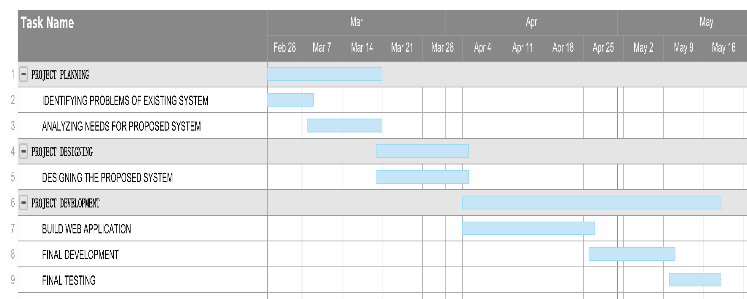

## 3.4 Process/Activity wise Resource Allocation

Now talking about Process/Activity wise Resource Allocation. My Process/Activity wise Resource Allocation chart is given below. There is my task combination. I always want to do submit my work on time and complete as much as possible.

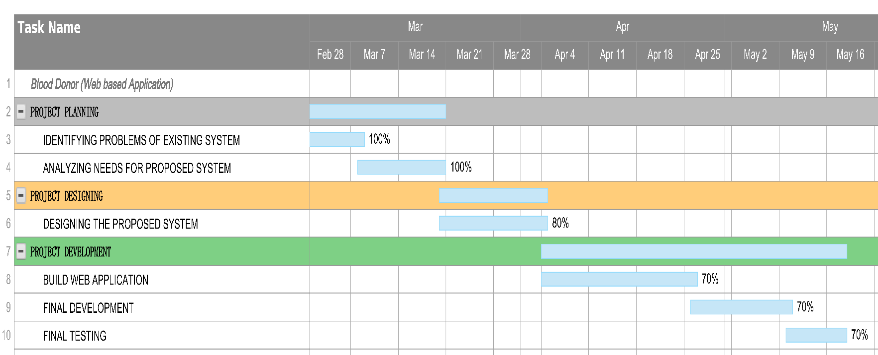

## 3.5 Estimated Costing

|  |  |
| --- | --- |
| Project: BLOOD DONOR | |
| COSTING | |
| ITEM | COST (TK) |
| HOSTING (HOSTINGER) | 8245 |
| DOMAIN (.TK) | FREE FOR 1 YEAR |
| SSL | COMPLEMENTARY WITH HOSTING |
| TOTAL | 8245 |

For the proposed system, domain hosting was needed for web applications. All these resources were provided by the company for the project completion.

# Chapter 4 Methodology

The Blood Bank web application is following the methodology of the Iterative Waterfall Model. The internet has had a significant impact on the process of web development and information system. However, there has been little research. Nowadays through the internet, anybody can access any site and order to receive blood. So, for this user-friendly project, I am using Html, CSS, Bootstrap, PHP to build. It is responsible for any device like smartphone, Laptops, computer, Tablets and so on. After using Bootstrap, it can be visible for any ratio of the screen.

**Html**-It gives the basic structure of the project. It is actually browser-friendly code .everything is visible in your browser and can add the logo, buttons, using this HTML code.

**CSS-**It gives the style of the project. It gives the shape and size of the project. Have to add a stylesheet on an HTML file rather than it not working or can't give you the beauty which your project and clients want from you.

**Bootstrap-** Basically, Bootstrap is not a code it removes your ratio problem that the main reason it can access from any device and any ratio screen. Any screen ratio it's not a problem when you use bootstrap.

**PHP**- using this PHP I created the front end and back end, the full project and image and text are used in PHP format that helps me to connect to the database.

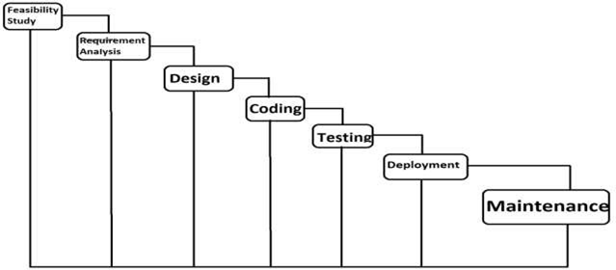

Figure: Work flow steps

Figure: Waterfall Model

**Advantages:**

* Simple to comprehend and apply.
* Testing in each phase.
* After each phase, documentation is available.
* An iterative model requires less time spent on documentation and more time spent on designing.

**Disadvantages:**

* Once an error is detected at any face, it may be necessary to modify the preceding subsidy faces.
* Changes between phases can be extremely difficult to manage, and there is the possibility of blocking, which can cause the process's productivity and efficiency to be significantly reduced.
* This model makes no mention of risk.

**Advantage of Model in this System**

* Easy to understand.
* It is the fundamental model from which all othe
* After each phase of development, errors are detected.
* It is a Single and Small Project.
* It is easily adaptable to the ever-changing needs of the project as well as the client.
* Small teams work better using the agile development process as one developer can.
* Possess multiple skills and can utilize them at several stages of the iteration

without conflicts.

# Chapter 5 Body of the Project

## 5.1 Work Description

In my project, I have simple things on it. First of all, I have developed the user interface and see how it looks. Create a responsive home button and give the main BloodBank home Link. Add services of our company which give users vast knowledge about, who can donate blood, and who can receive blood and available blood samples. It also shows health tips for patients. The normal thing every website has about us.

Gives the basic contact with us, location of our company, social media icon (so the patients can use our Facebook page, and communicate with us 24hrs.),email address. The basic Privacy policy and terms and conditions.

## 5.2 System Analysis

### 5.2.1 Six Element Analysis

|  |  |  |  |  |  |  |
| --- | --- | --- | --- | --- | --- | --- |
| **System Roles** | | | | | | |
| **Process** | **Human** | **Non- Computing Hardware** | **Computing Hardware** | **Software** | **Database** | **Communication & Network** |
| Access Resources | Customers  -View the resources | N/A | -  Necessary devices (e.g., pc, laptop, phone) | -Browser  -Website | -Stores all the resources DBMS((SQL) | -  Internet/broadband  - Mobile data |
|  |  |  | -  Internet cable |  |  |  |
| Communication between customers | Customer  -Through social media | -N/A | -  Necessary devices (e.g., pc, laptop, phone) | -Browser  -Website | - Stores all resources DBMS((SQL) | -  Internet/broadband  - Mobile data |
|  | | | | | | |

### 5.2.2 Feasibility Analysis

A feasibility study is conducted to determine whether the project, upon completion, will serve the organization's purpose for the amount of work, effort, and time spent on it. A feasibility study enables the developer to envision the project's future and usefulness. A feasibility study evaluates a system proposal's workability, which includes the impact on the organization, the ability to meet user needs, and the efficient use of resources. In order to determine the viability of an idea, a feasibility study is conducted. For example, it can be used to determine whether a project is legally and technically feasible, as well as economically viable. It indicates whether or not a project is worth investing in; in some cases, it indicates whether or not a project will be completed. Feasibility studies enable businesses to identify and organize all of the details that are required to make a business successful in order to maximize profits.

A feasibility study assists in identifying logistical issues, as well as nearly all other business-related issues and their resolutions. Additionally, feasibility studies can result in the development of marketing strategies that persuade investors or a bank that investing in the business is a sound investment.

A feasibility study is conducted to determine the viability of a proposed system in terms of technical, operational, and economic factors. After conducting a feasibility study, we can gain a clear understanding of the system's advantages and disadvantages.

**Technical Feasibility:**

The proposed system is developed using the front-end tools Active Server Page, VB Script, and HTML and the back-end tool Oracle 8.

The proposed system requires a Personal Web Server to process user requests. The Web browser is used to access web pages contained within the Windows operating system. The proposed system will run on Windows 10, Windows 9, Windows 9x, Windows NT, and Windows 2000. Because Windows is a very user-friendly and graphical operating system, it is extremely simple to use. All necessary hardware and software are commercially available. As a result, the system is technically viable.

**Operational Feasibility:**

The proposed system is operationally feasible for the reasons listed below.

* The customer benefits the most because the majority of his time is saved.
* The customer is attended to at his place of employment.
* The proposed system's cost is almost insignificant in comparison to the benefits gained.

**Economic Feasibility:**

Due to the low cost of the necessary hardware and software, the initial investment is the only cost and does not require further enhancements.

As a result, it is economic. The system is feasible in every way, which encourages participation in the design process.

### 5.2.3 Problem Solution Analysis

The problem solution Analysis are:

* Develop a workable solution for managing blood bank management activities.
* Establish a communication system that is effective between donors, hospitals, donors, and recipients.
* Coordination device for the activities of blood banks and blood donation centres.

### 5.2.4 Effect and Constraints Analysis

It is planned to develop an online blood bank system, which will be a web-based database application system that will allow blood banks or blood centers to publicize national blood donation events while also allowing members of the public to make online reservations and requests for blood. In addition to keeping track of all donors and recipients, the system keeps track of blood donation programs and blood that is rejected. Using computerization, this project will modernize the blood and donor management system in a blood bank in order to improve the efficiency of record management in the face of the growing volume of data.

**Benefits:**

* Secure and safe storage of records.
* Simple search for the required blood.
* Simple management of blood stock information.
* Quick service.

**Goals:**

1. Providing the blood bank with publicity and advertising programs for the donation of blood.
2. To allow potential beneficiaries to search for, match and submit blood requests for voluntary donors. To assist the blood bank in managing donors and blood stocks efficiently by recording donor and blood information.
3. Improve blood inventory efficiency by notifying staff of blood banks when the blood supply is below the necessary level or when the blood supply has expired.
4. Retain a centralized and synchronized donor and blood inventory database.
5. Enable data and information to be stored and retrieved immediately.

## 5.3 System Design

### 5.3.1 Rich Picture

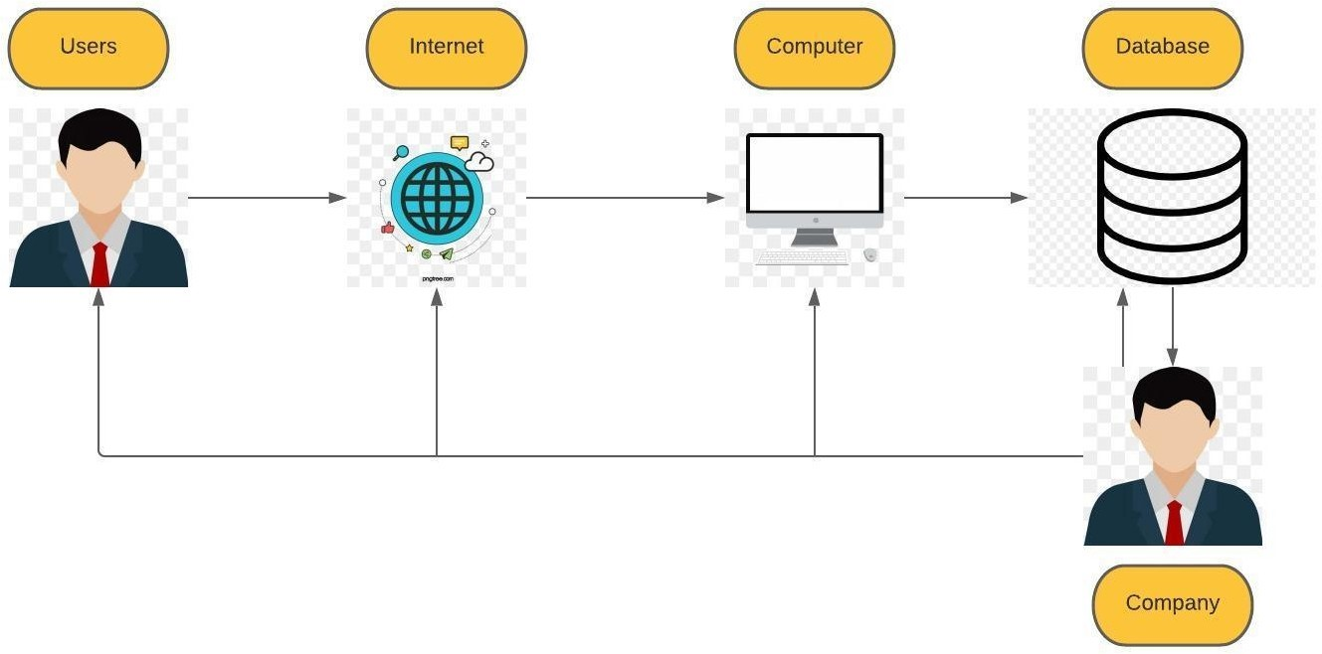

### 5.3.2 UML Diagrams

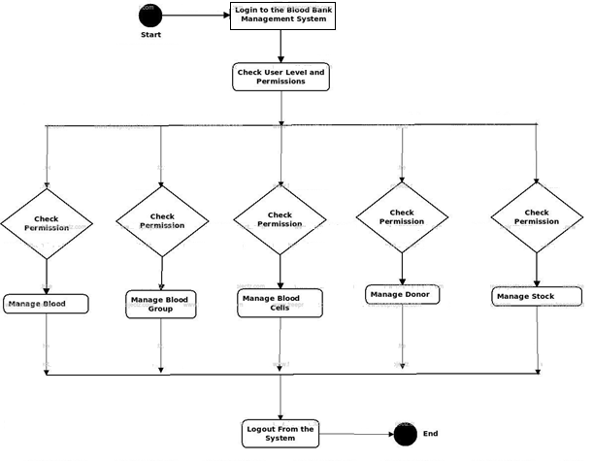

### 5.3.3 Functional and Non-Functional Requirements

Numerous software requirements are included in the functional requirements of the Blood Bank Management System, which encompasses a variety of processes, including registration, check-out, report generation, and database management.

**Registration Process**

* Patient Registration: The Blood Bank Management system enables front-desk personnel to enroll new patients.

● Assigning an ID to patients: the blood bank allows the staff of the front desk to provide each patient with a single identifier and then to add it to the records.

The ID is valid for the duration of the hospital stay of the patient.

**Report Generation**

* Compulsory Patient Information: Each patient must provide certain information, such as their telephone number, first and last names, personal health number, postal code, country of country, address of city and number of the patient etc.
* Updating patient information: The blood bank management system allows users to update patient information according to the compulsory information included.

**Non Functional Requirements**

Numerous software needs are covered by the non-functional requirements of the Blood Bank Management System, which include a variety of processes including safety, performance, maintenance, and reliability.

**Security:**

* Login ID and Password: A Login ID and password are required for all users that access the system.
* Identification of patients: The system designed requires patients to use the phone to identify themselves.
* Changes: Any database changes, like insert, delete or update, can be synced and implemented only quickly by the ward administrator.
* Front Desk Staff Rights: Front desk staff can view all data in the Blood Bank Management system as well as add new patient records, but they cannot change any data in the system.
* Administrator rights: The administrator has access to all data in the Blood bank Management System and can view and modify it.

**Maintainability:**

* Backup: The system is efficient at backing up data.
* Errors: The system will track and log all errors.

## 5.4 Product Features

### 5.4.1 Input

Here is the product features inputs of my project "Blood Donor – a web-based Blood Bank". You can see all the inputs to the system and the picture illustrating the process to make understanding more clear.

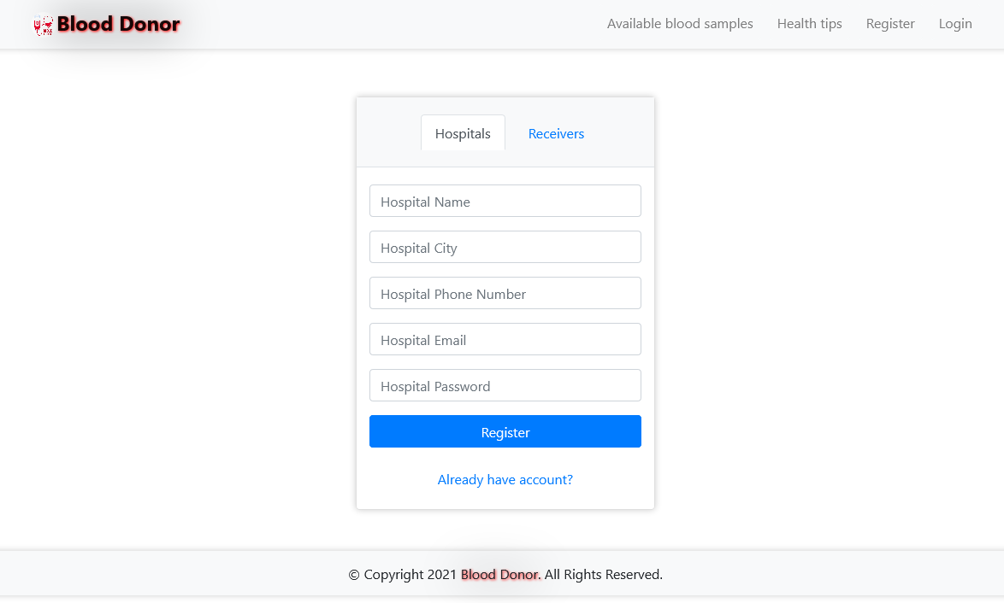

Figure: Hospital Registration page

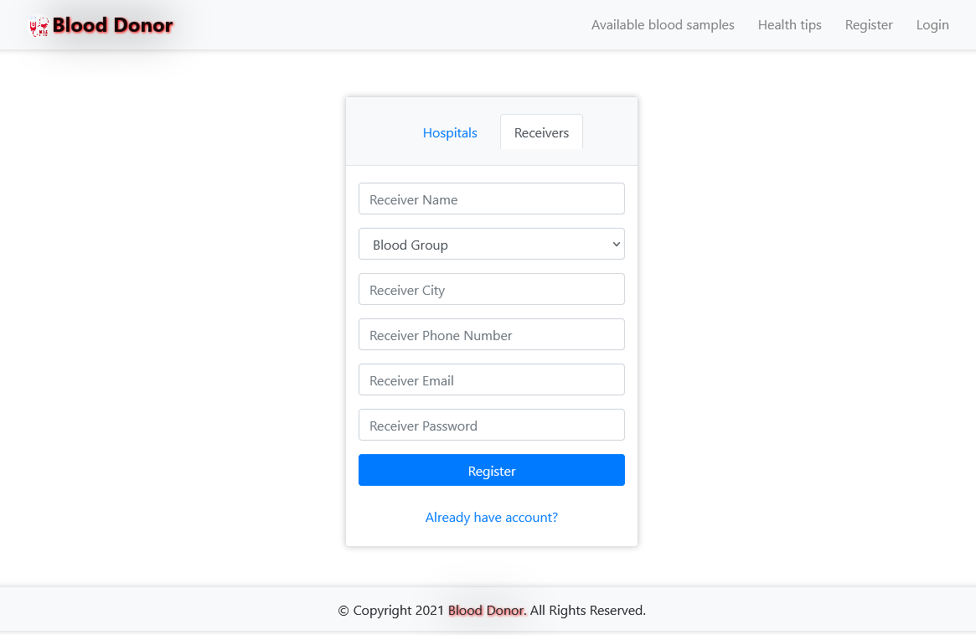

Figure: Receiver Registration page

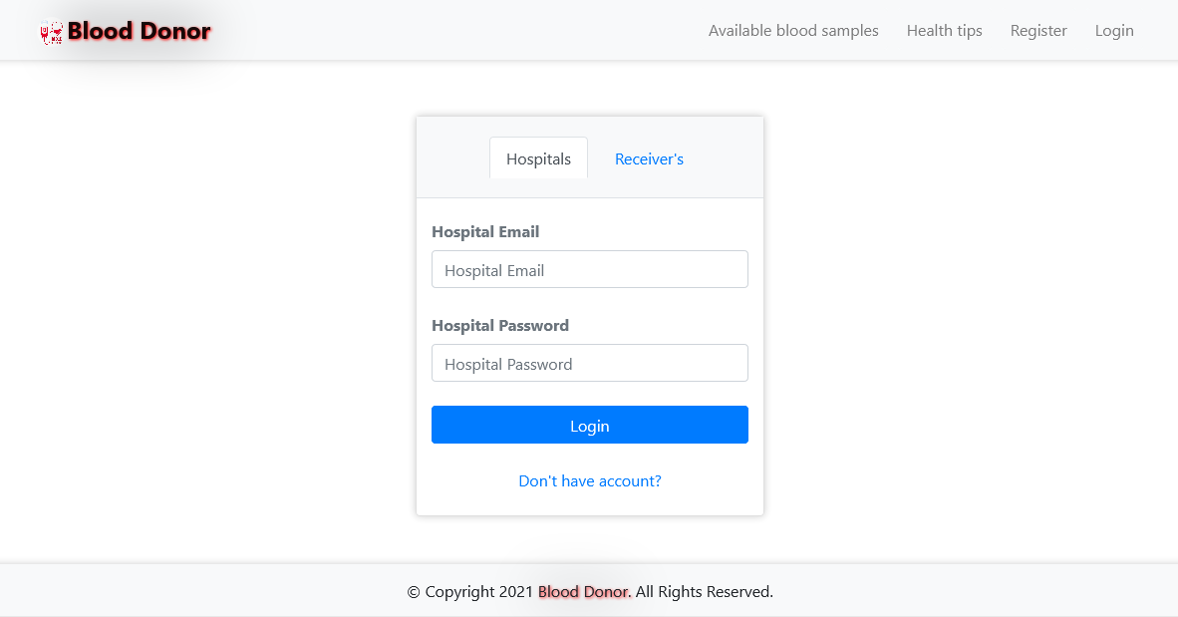

Figure: Hospital login page

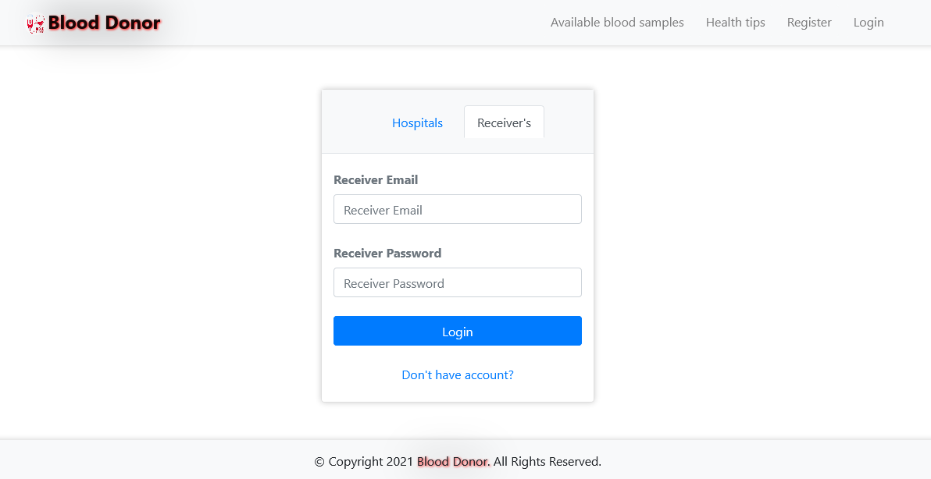

Figure: Receiver Login page

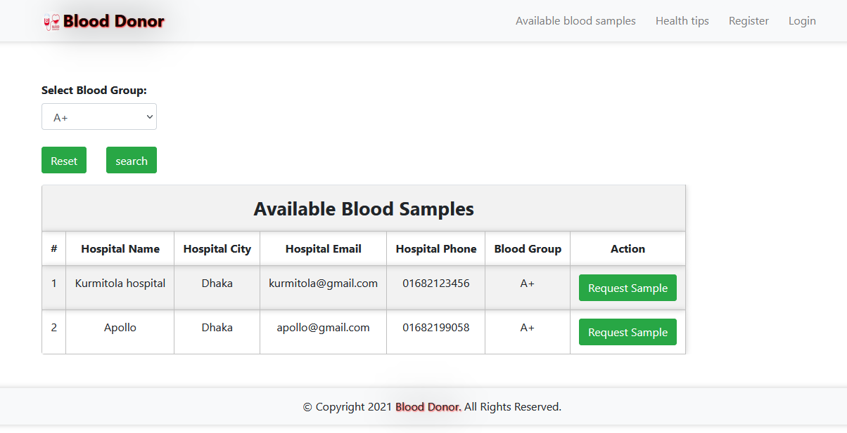

Figure: Searching for a specific blood group.

### 5.4.2 Output

Here is the product features outputs of my project "Blood Donor – a web-based Blood Bank". You can see all the outputs of the system and the picture illustrating the process to make understanding more clear.

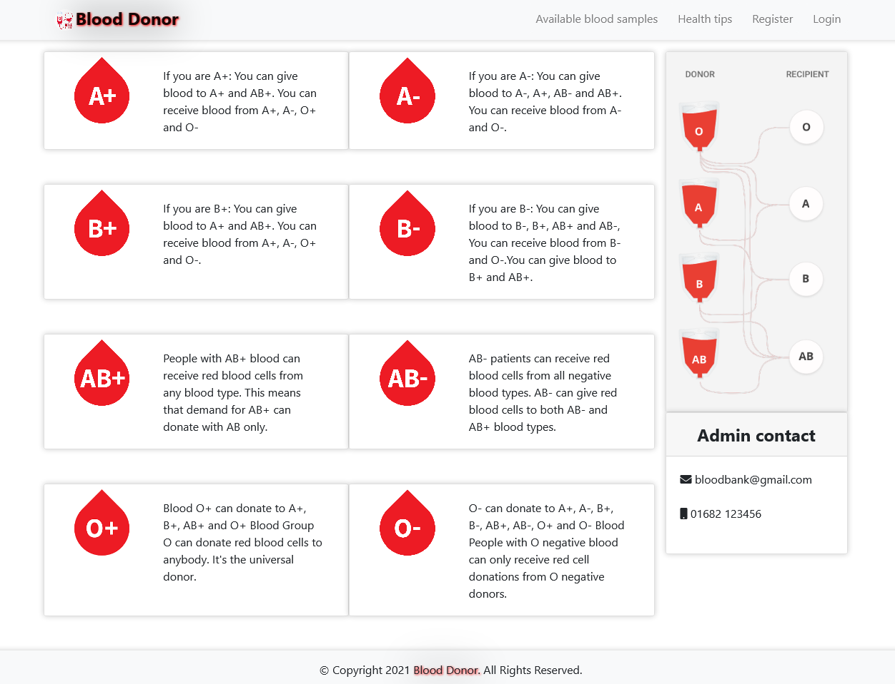

Figure: Home Page

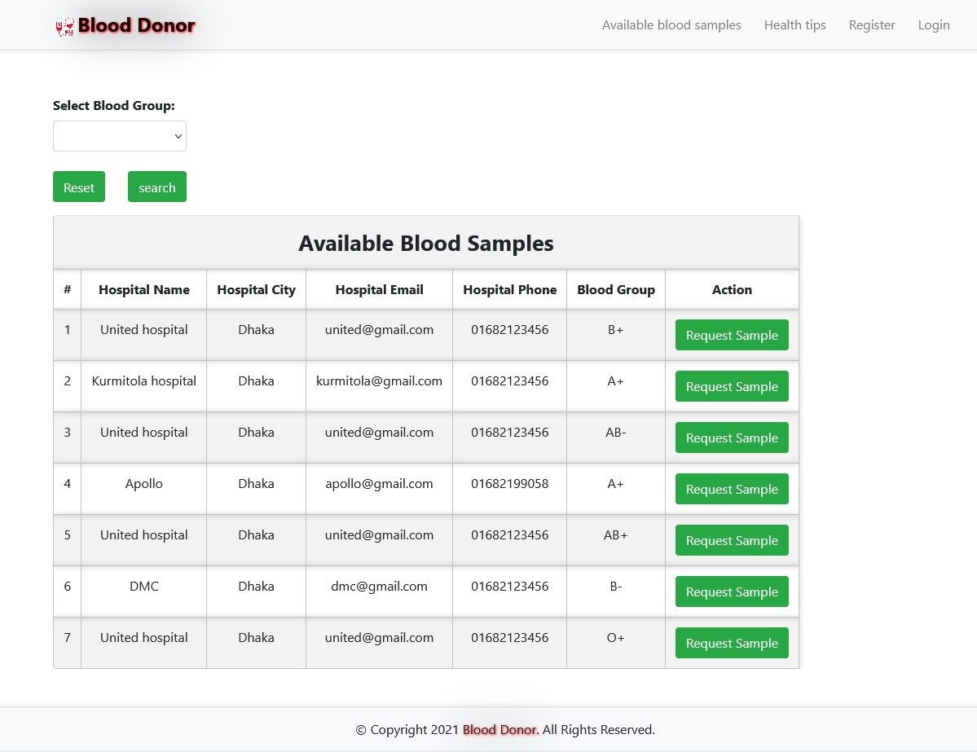

Figure: Available blood Samples

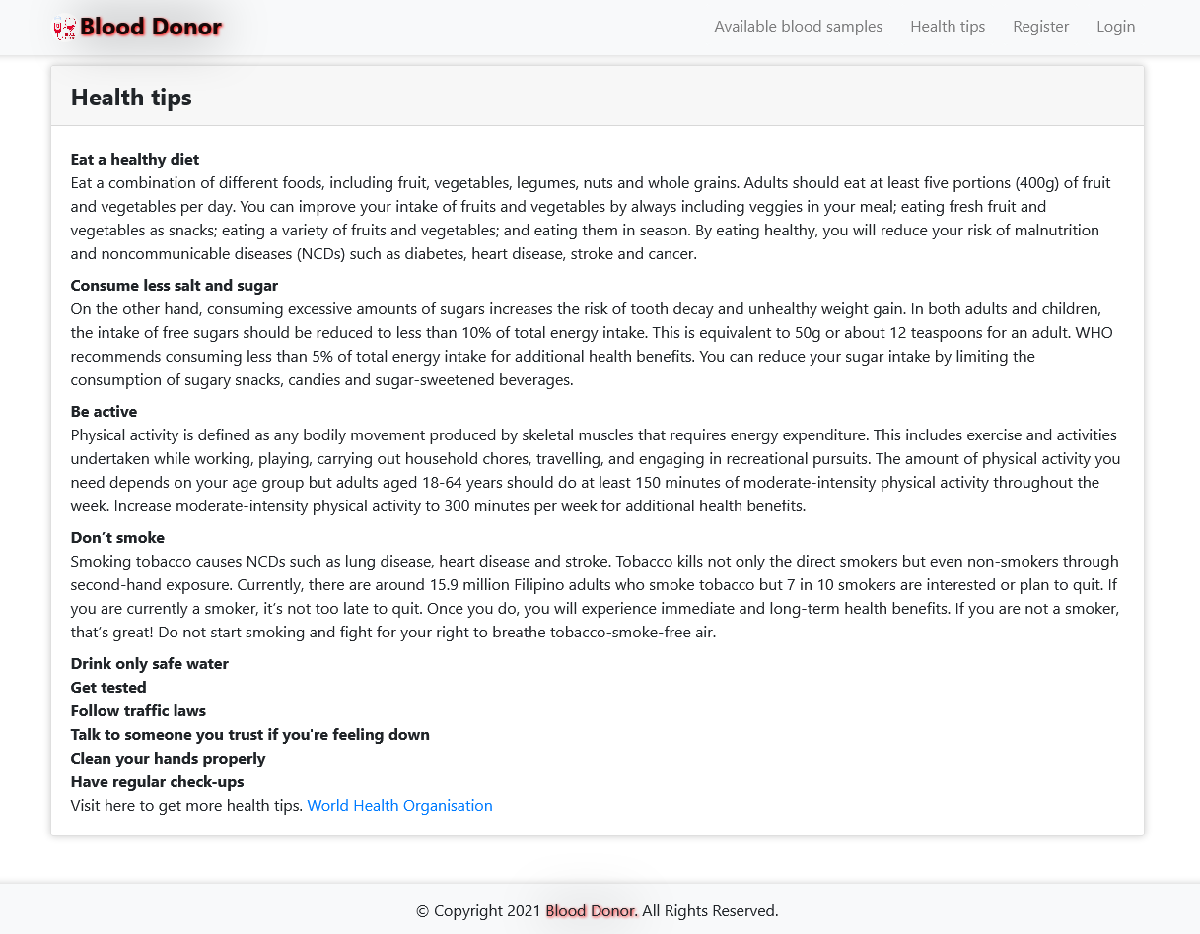

Figure: Health Tips (Blogs)

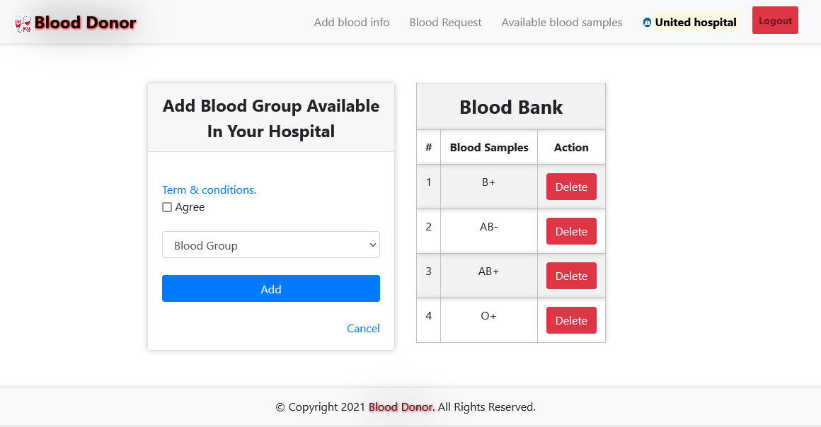

Figure: Add available blood group (Only Hospital Access)

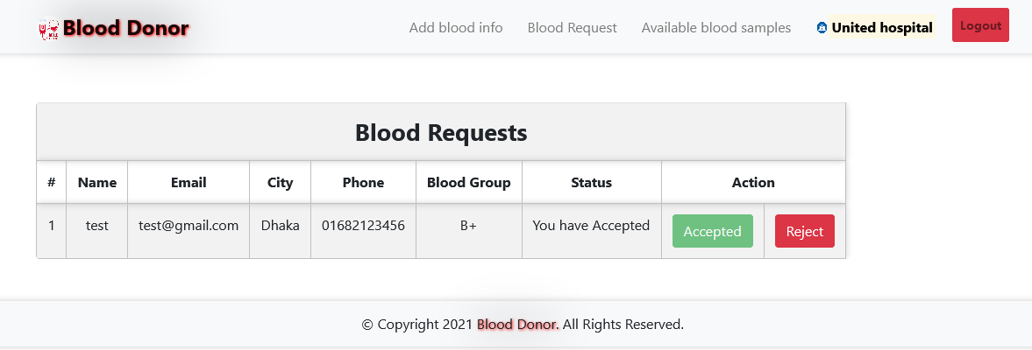

Figure: Blood Requests (Only Hospital Access)

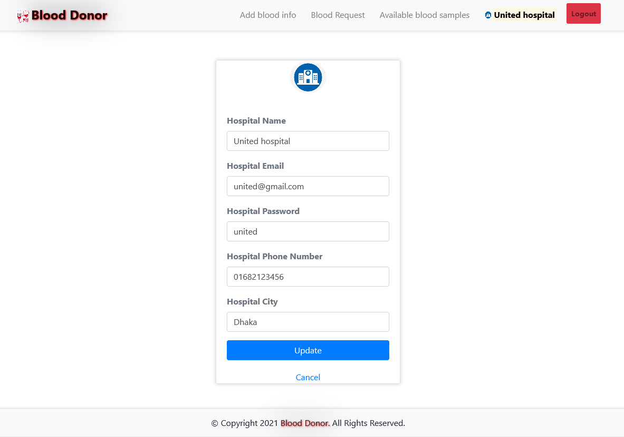

Figure: Hospital Registration Information Update page

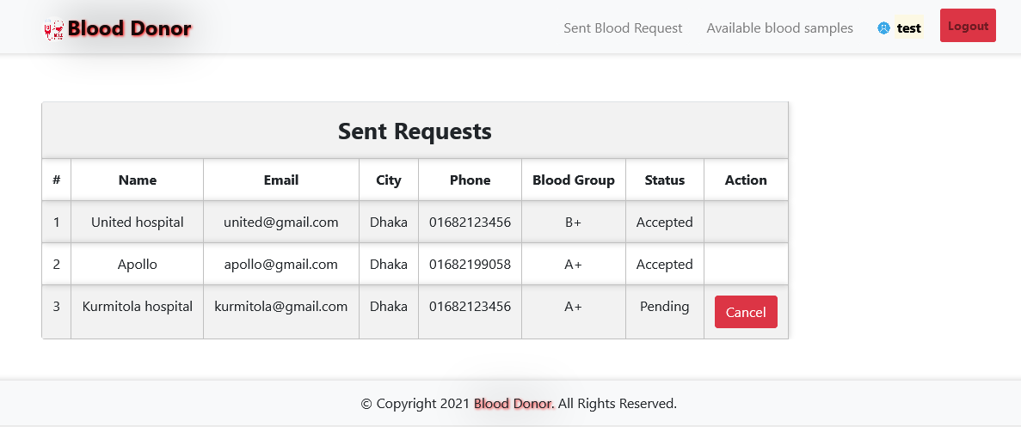

Figure: Sent Requests (Receiver Access)

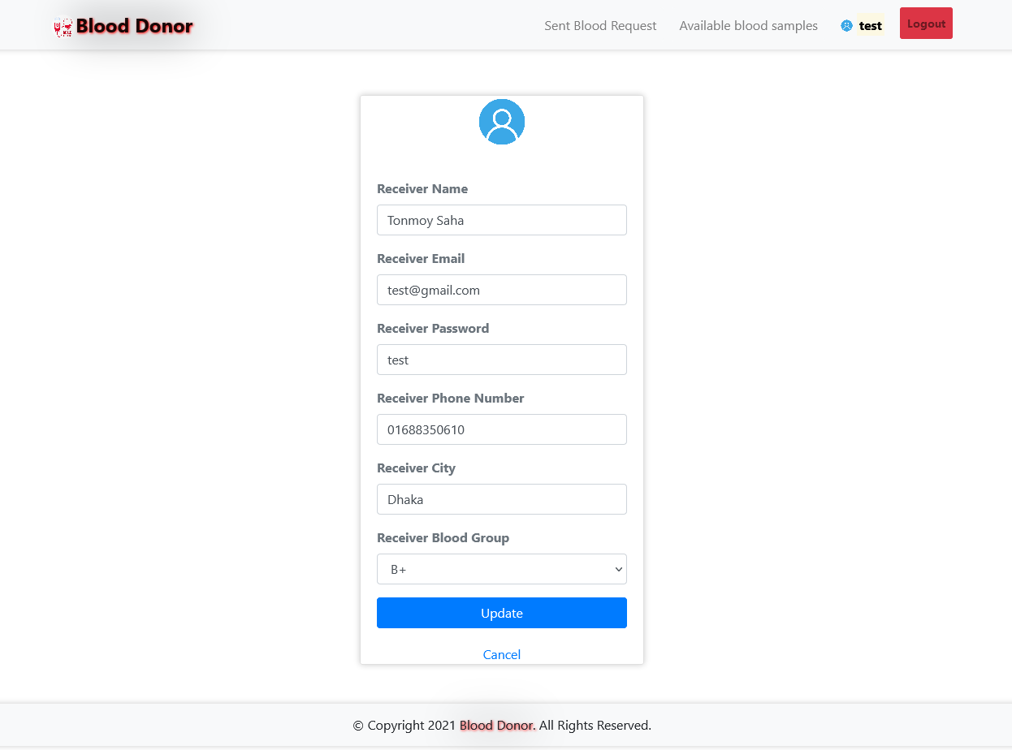

Figure: Receiver Registration Information Update page.

### 5.4.3 Architecture

Our new system, which will be a website, will be hosted on an Apache web server. The overall architecture is managed centrally. In this sense, the system is installed on a central server and is accessed and data collected via browsers on various devices distributed throughout a distributed area, all of which remain connected to the central server.

In comparison to existing blood bank management systems, the new system is designed to be used by multiple blood bank centers while maintaining the data security and privacy of individual blood banks while also providing equal access to other data and information, such as donor and recipient information.

The new system is designed to be "deployed once and used anywhere," in contrast to some research that suggests management activities should be carried out on standalone systems running on individual computers in blood bank centers. Depending on the type of user who logs in, the system's entire functionality will be accessible via the internet.

# Chapter 6 Results & Analysis

Here are the product results and Analysis of my project "Blood Donor – a web-based Blood Bank". You can see all the results of the system and the picture illustrating the process to make understanding more clear.

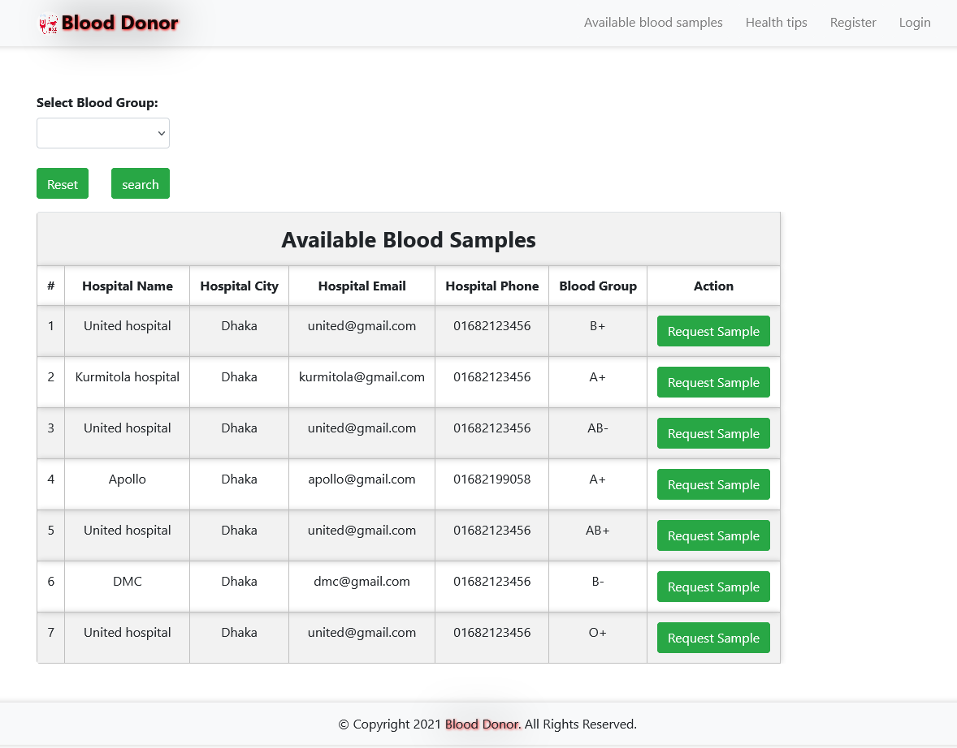

Figure: Available blood samples with hospitals list

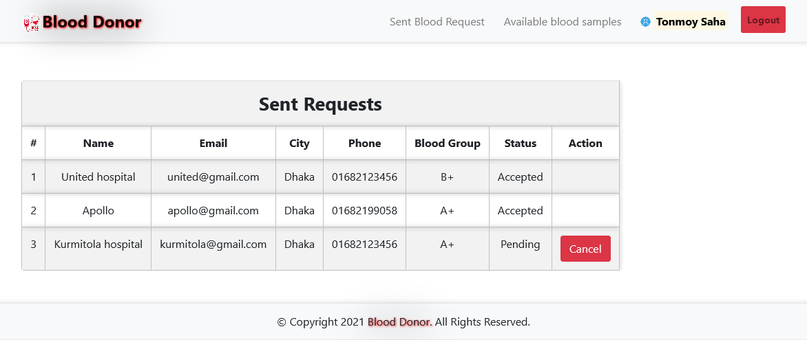Figure: Request sent by blood receivers (who needs blood).

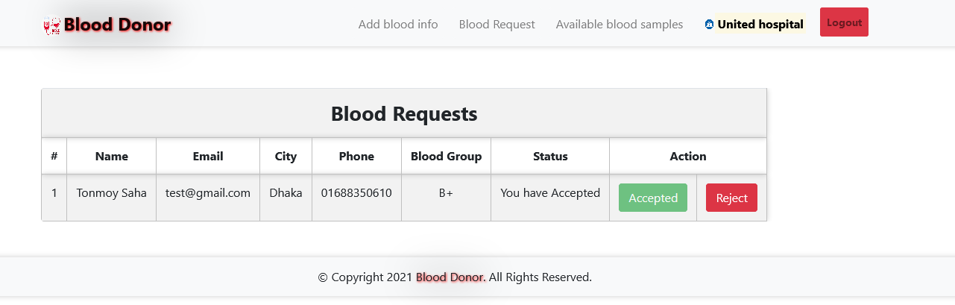

Figure: Blood request view and accept/reject portal for hospitals.

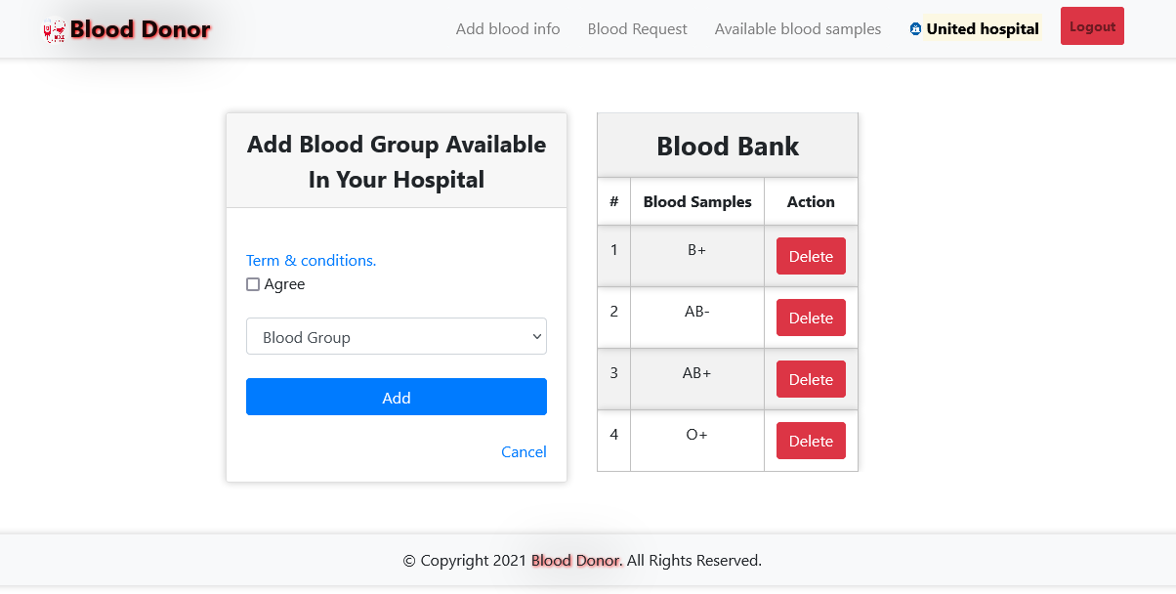

Figure: Add available blood groups by Hospitals.

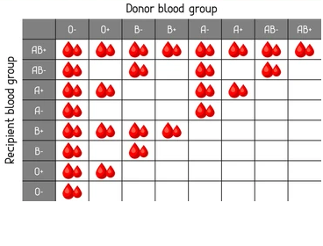

Figure: Recipient blood group vs Donor blood group.

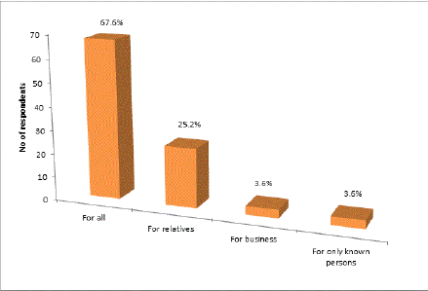

Figure: The interest of blood donor for specific reasons.

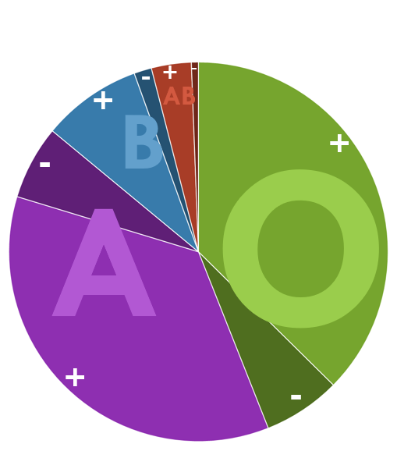

Figure: The most common requested blood groups in Dhaka.

# Chapter 7 Project as Engineering Problem Analysis.

## 7.1 Sustainability of the Project/Work

Some positive factors, which will ensure the sustainability of the project, include:

* Budget increases for the National Blood Transfusion Service beginning in 2007, as indicated by the Ministry of Health.
* Existence of a network of Dhaka-based transfusion specialists willing to assist with further development.
* The new National Strategy for Blood Safety and Donation to Blood Services will enhance blood bank operations.
* Among the risks that could jeopardize the project's viability are the following:
* Inadequate capacity to organize a truly national service.
* Lack of a well-defined plan for implementing a National Blood Transfusion Service within the allocated budget, with a particular emphasis on rural areas.

## 7.2 Social and Environmental Effects and Analysis

Transfusions are a critical component of medicine, and the safety of this product is critical. Transfusion-transmitted infections can cause serious complications and are a major public health concern. Developed regions have mitigated this risk through a variety of strategies, including donor screening and deferral; however, as Flaherty points out, additional risk reduction can be achieved through improved blood screening and pathogen inactivation strategies. A screening approach based on a (self-reported) questionnaire as a standard procedure for potentially contaminated blood donors may not be sufficient in the absence of an effective blood screening test in the case of diseases. Additionally, a deferral strategy based on prior travel may inadvertently exclude a sizable number of potential blood donors. Flaherty considered the feasibility of relaxing blood donation restrictions for certain infectious diseases based on available evidence indicating a low risk of transfusion-transmitted infections when travelling to specific locations.

As previously stated, climate change favourable to vectors is a significant factor influencing the changing geographic distribution of numerous infectious diseases. Variation in the distribution of infectious diseases as a result of climate change that favours vectors is also becoming a significant factor in the evaluation of blood donors. Certain communicable diseases, such as the Zika virus, are of particular concern, as a large proportion of infected individuals may present as healthy donors. This is especially critical when the sensitivity and specificity of screening are unknown. Even more cause for concern are diseases for which there is no effective and efficient testing protocol. This can rule out a large number of potential blood donors solely based on their travel history. While the majority of questionnaires assess donors based on their foreign travel, with the spread of infectious diseases, this concept may be changing as well. As has been demonstrated with a number of emerging infections (e.g. Zika virus, Babesiosis, and Chagas disease), transmission can also cause travel issues within a geographical region (e.g. the United States of America), thereby extending concerns about the blood supply to those travelling within a country. These occurrences will necessitate the development of a new strategy for blood donor selection.

# Blood Donor Associations' health and social impact: A Social Return on Investment (SROI) analysis

* Associations of blood donors provide quantifiable benefits to their members.
* The overall experience of blood donation or volunteering results in positive changes.
* SROI is used to investigate phenomena that are largely unexplored.
* The intangible effects of donation, such as social and human capital, are quantifiable.
* Social impact evaluation allows for [stakeholder engagement](https://www.sciencedirect.com/topics/social-sciences/stakeholder-engagement) in nonprofit organizations.

## 7.3 Addressing Ethics and Ethical Issues

As web developer, we are responsible for shaping how users interact with the internet. By making ethical and user-centred decisions, we can build a better web service for everyone.

**Assuring Blood Quality:** To ensure that only healthy human blood is delivered and that the blood is free of contamination. So that no bad blood is collected, delivered, or purchased for the purpose of increasing profits.

**Ensuring Right Blood Type:** Ascertaining the correct blood group and performing blood tests (disease-free). This is critical because many drug addicts wish to donate blood for financial gain. Their blood may cause health problems.

**Web applications should be accessible to all.**

* Constructed on the foundation of progressive enhancement.
* Make accessibility a priority.
* Create inclusive forms.
* Conduct user testing with actual users.

**Web applications should be sensitive to the privacy and security of their users**

* Utilize HTTPS wherever possible to ensure security.
* Consider the user's tracking preferences.
* Provide users with transparent information about how their data is used.
* Allow users to export their data.
* Secure user data.

# Chapter 8 Lesson Learned

## 8.1 Problems Faced During this Period

During my Internship period at JBL Drug Laboratories, there were many problems that I had to go through. The first was the Covid19 period made it risky to travel to work station. I had to do work from home during the lockdown period. When doing work from home, interactions with seniors and colleagues became a little difficult and many faced network problems and issues while doing google meet meetings and discussions.

Learning from the work environment was also very difficult as I had to take and understand my work with extra efforts. The colleagues are helpful but have their own deadlines to meet so are often busy.

The physical office was more preferable as I could connect with senior officers and developers. But due to Covid19 concerns, internship sessions were mostly conducted online as work from home to minimize the spreads of disease.

In my opinion, 3 months are not proper for adapting and understand the overall workflow and operations of a company which is involved with so many different projects and different department. For lockdown, our office is closed since the last of April. At this time, we work from home. It was a little challenging but we have done it online. In this case, we use Discord and google classroom for the meeting. It was less time consuming but the same problem was there.

It was extremely difficult for me to maintain the same level of productivity as the rest of the team. Because they are highly skilled and knowledgeable in their field. I was required to work full-time hours because my official hours were 10:00 am. to 5:00 pm. Due to my lack of experience, it was difficult for me, but I enjoy it.

## 8.2 Solution of those Problems

Although most of the problem faced at JBL was mostly due to work from home and Covid19 pandemic. But I believe this problem will get solved when the pandemic ends. My supervisor helped me a lot and guided me to every task. Having such a helpful supervisor also solved many problems. But there are always scope for improvement. Below are some recommendations for improvements and problem solutions.

After completing the internship in JBL Drug Laboratories IT Department, I have some recommendation for this training and development in this department. These are:

• **Promotional activities:** Despite the fact that they work on a large number of projects, which is more than enough for this company. Nonetheless, my recommendation will be more promotional in nature.

• **Emphasize training as an investment:** Although initial costs may seem high, emphasize that training is a long-term investment in your staff growth within your company.

**• Systems maintenance:** Since the JBL Drug IT Department works for many systems and their customers, they need careful system maintenance by responsible management.

• **Maintain the standard quality of products:** Standard quality of products and services should be maintained.

•**Target your requirements:** Identify the specific competencies you need to improve and the time frame for meeting your training goals to ensure optimal payback.

• **Encourage a culture of learning:** Express to all employees that your organization cares to improve their skills and that each employee, whether training or not, wants to remain competitive within their capacities.

• **Choose high-quality** trainers: Ensure that the trainers hired are educators and that their materials will serve as valuable resources in the future.

• **Make it an ongoing process:** Do not restrict the training to new employees and try to get as many people as you can to benefit from further education.

**• Follow the results:** A training programme, unless you monitor its progress, will not be effective. Choose a metric, for example, productivity or profit, to help determine your return on investment for training and achieve tangible results.

# Chapter 9 Future Work & Conclusion

## 9.1 Future Works

With the current computing trend toward cloud technology, our CBBR system was designed with the future in mind. As a result, it is scalable and easily transformable into a cloud server that can be accessed by multiple blood banks to obtain required data and utilize various functionalities. However, in the short term, we will examine SMS integration, which will enable users to receive alerts and notifications via their mobile phones.

In the short term, however, we will investigate SMS integration, which will allow users to receive alerts and notifications via their mobile phones.

* Make Donor categories A, B or C based on lifestyle and fitness.
* Direct Donor to Receiver connection.
* Real-time tracking of Blood bag delivery (Like Uber)
* SMS service support
* Chat Service Support
* Connect to the Hospital software via API to our Web system

## 

## 9.2 Conclusion

# Prior to the completion of this project and report, a comprehensive examination of the blood bank management system was conducted based on recent research conducted by various authors, and facts were gathered that aided in the discovery of the system's inconsistencies. Following an in-depth examination of these issues, a solution was developed to satisfy the requirements of a more sophisticated computer system. This system, dubbed the centralized blood bank repository, was instrumental in resolving all of the previous blood bank infrastructure's issues. Through this system, blood banks/centres, hospitals, patients, and blood donors will be able to benefit from a variety of functionalities and gain access to a vast amount of data, thereby simplifying and expediting the process of blood donation and reception.

# Bibliography

1. C. A. Catassi and E. L. Peterson. (September) A Framework for a Smart Social Blood Donation System Using Mobile Cloud Computing (2016).

http://doi.org/10.5121/hiij.2014.3401

1. C. Ekanayaka & C. Wimaladharma (2015). “A system based on cloud computing and mobile devices for healthcare applications,” Int. Symp. Technol. Soc. Proc., vol. 1, pp. 1–5. (2016).
2. P. Esah & S. Ab Rahman (2011). System for Blood Bank Management.

[Accessed February 22, 2015].

1. "Cloud-based Smart Blood Bank as a Service" - Journal of Computer Engineering, e-ISSN: 2278-0661, p-ISSN: 2278-8727, Vol. 18, No. 2, Ver. I (Mar-Apr. 2016), pp. 121-124.
2. Asian Journal of Transfusion Science articles are made available here courtesy of Med know Publications. Asian J Transfuse Sci. 2009 Jul; 3(2): 57–59. Asian J Transfuse Sci. 2009 Jul; 3(2): 57–59.

<http://dx.doi.org/10.4103/0973-6247.53871> “http://www.ncbi.nlm.nih.gov/pmc/articles/PMC29204 72/” N. Choudhury.

1. Noushin & Hessam Ashrafi (2008).

Object Oriented Systems Analysis and Design, Pearson Higher Education, United States of America.

1. Anon, (2015). [online]

The World Health Organization's World Blood Donor Day campaign kit is available at: [http://www.who.int/worldblooddonorday/campaignkit/WBDD GlobalNeed English.pdf](http://www.who.int/worldblooddonorday/campaignkit/WBDD%20GlobalNeed%20English.pdf). [Accessed February 26, 2015].

1. D. J. Wake, Noushin Ashrafi, and Hessam Ashrafi (2008).

Object Oriented Systems Analysis and Design, Pearson Higher Education, United States of America.